Create a static folder inside app folder

And add a new folder with any name

And then paste or create new files here

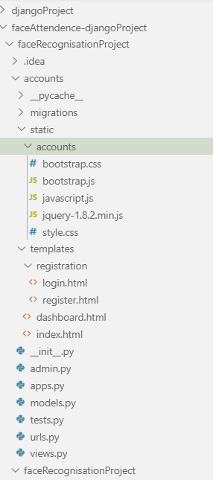

Now go to settings file and paste

STATICFILES_DIRS = [

    os.path.join(BASE_DIR,'static'),

]

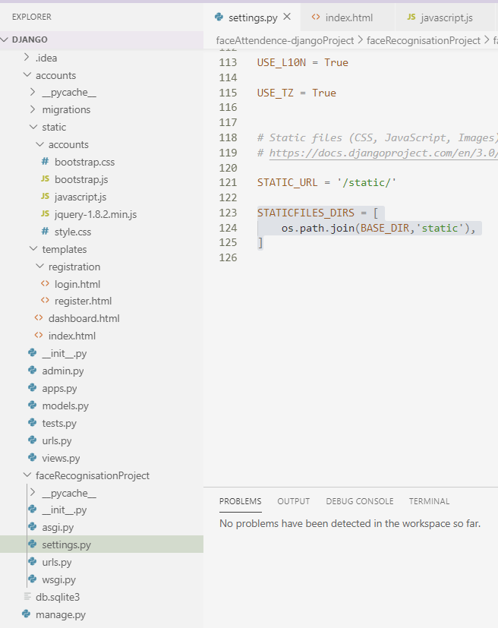

Now in html file go and add

{% load static %}

In <head>

<script *src*="{% static 'accounts/jquery-1.8.2.min.js' %} "></script

